Table of Contents
1 Introduction 2
1.1 ELECTION COMMISSION OF PAKISTAN 2
1.2 No Executive Interference 2
1.3 Budget and expenditure 3
1.4 FUNCTIONS OF CHIEF ELECTION COMMISSIONER 3
1.5 Questionnaire with Election Commission of Pakistan 4
2 Business Organization Chart with respect to Management 10
3 Business Organization Chart with respect to types of Elections 11
4 Scope 12
5 Summary of Requirements 12
6 Over Specify Entities from Abstract 12
7 Perform Refinement 13
8 Context Diagram 14
9 Capture "shall" Statements 15
10 Allocate Requirements 16
11 Priorities Requirements 17
12 Requirements Traceability Matrix 20
13 High Level Usecase Diagram 24
14 Analysis Level Use case Diagram 25
15 Use case Description 26
15.1 UC_Prepare_ElectorlRoll 26
15.2 UC_Candidate_Nomination 27
15.3 UC_Prepare_Symbol _CandidateList 28
15.4 UC_VoterList_DRODistribution 29
15.5 UC_VoterList_RODistribution 30
15.6 UC_VoterList_PODistribution 32
15.7 UC_Validate_Voter 33
15.8 UC_Cast_Vote 34
15.9 UC_Compile_Submit_POResult 36
15.10 UC_Compile_ROResult 37
15.11 UC_Submit_ROResult 38
15.12 UC_Compile_DROResult 39
15.13 UC_Submit_DROResult 40
15.14 UC_Compile_FinalResult 41
15.15 UC_Prepare_DROList 42
15.16 UC_Prepare_ROList 44
15.17 UC_Approve_ROList 45
15.18 UC_Prepare_PollingStationList 46
15.19 UC_Approve_PollingStationList 47
15.20 UC_Prepare_PO_APO_PollingStaffList 49
15.21 UC_Approve_PO_APO_PollingStaffList 51
15.22 UC_Cast_MobileVote 53
15.23 UC_UpdateResultPOToRO 55
15.24 UC_UpdateResultROToDROCEC 56
- Introduction
Pakistan is a Federal Republic and is known as the Islamic Republic of Pakistan. It came into existence on 14th August, 1947. The territories of Pakistan comprise the provinces of Punjab, Sindh, North-West Frontier and Balochistan, the Islamabad Capital Territory i.e. the Federal Capital, the Federally Administered Tribal Areas (FATAs) and such states and territories as are or may be included in Pakistan whether by accession or otherwise. It has a population of approximate 160 Million and a territory spread over 7,96,096 square kilometers.
The Election Commission of Pakistan is an independent and autonomous constitutional body charged with the function of conducting transparent, free, fair and impartial elections to the National and Provincial Assemblies. The holding of elections to the office of the President and the Senate are, however, the functions of the Chief Election Commissioner. Under the existing laws the conduct of Local Government Elections is also the responsibility of the Chief Election Commissioner.
  - ELECTION COMMISSION OF PAKISTAN
The Election Commission of Pakistan is an independent and autonomous constitutional body charged with the function of conducting transparent, free, fair and impartial elections to the National and Provincial Assemblies. The holding of elections to the office of the President and the Senate are, however, the functions of the Chief Election Commissioner. Under the existing laws the conduct of Local Government Elections is also the responsibility of the Chief Election Commissioner.
Under the Election Commission Order, 2002 (Chief Executive's Order No.1 of 2002), the Election Commission consists of the Chairman (Chief Election Commissioner of Pakistan) and four Members each drawn from the sitting judges of the High Courts of their respective Provinces. All the executive authorities in the Federation and in the provinces are constitutionally duty bound to assist the Chief Election Commissioner and the Election Commission in the discharge of his or its functions.
  - No Executive Interference
The Election Commission of Pakistan enjoys full financial and administrative autonomy and works independently of all government control.
The Election Commission performs its functions without interference of the executive. The Election Schedule for the conduct of General Elections as well as for the bye-elections is decided by the Election Commission or, as the case may be, by the Chief Election Commissioner.
The preparation of polling schemes, the appointment of polling personnel, assignments of voters and arrangements for the maintenance of law and order are under the control, supervision and directions of the Election Commission.
The Supreme Court of Pakistan in its judgment reported as Election Commission of Pakistan v. Javed Hashmi (PLD 1989 SC 396) held that in election matters the Election Tribunals appointed by the Chief Election Commissioner have exclusive jurisdiction and the jurisdiction of all courts in such matters was excluded. However, this is subject to an exception that where no legal remedy is available to an aggrieved party during the process of election or after its completion, against an order of an election functionary which is patently illegal/without jurisdiction and the effect of which is to defranchise a candidate, he can press into service Constitutional jurisdiction of the High Court.
The Supreme Court of Pakistan has since then consistently followed this judgment. Transaction of Business
The Commission transacts its business by holding meetings. All members of the Election Commission have equal status and say in the decisions of the Commission.
Judicial Review
Judicial Review of the decisions of the Election Commission can be sought in the High Court and the Supreme Court of Pakistan if the order suffers from a jurisdictional defect or is mala fide or coram non judice.
  - Budget and expenditure
The Budget of the Election Commission is provided by the Federal Government.
Any re-appropriation within the sanctioned Budget can be done by the Chief Election Commissioner without making any reference to the Finance Division.
Funds required for preparation of electoral rolls and the conduct of General Elections and bye-elections are provided in lump sum by the Finance Division according to the requirements of the Election Commission.
Further distribution of funds to the various functionaries is done with the approval of the Chief Election Commissioner.
  - FUNCTIONS OF CHIEF ELECTION COMMISSIONER
(1) To prepare electoral rolls for elections to the National and Provincial Assemblies and revising such rolls annually.
(2) To organize and conduct election to the Senate and fill casual vacancies in a House or a Provincial Assembly.
(3) To appoint Election Tribunals.
(4) To decide cases of disqualification of members of Parliament and Provincial Assemblies under Article 63(2) and Article 63A of the Constitution on receipt of reference from the Chairman or the Speaker or Head of the political party, as the case may be;
(5) To hold and conduct election to the office of the President as per Second Schedule to the Constitution of the Islamic Republic of Pakistan
(6) To hold Referendum as and when ordered by the President.
To make rules providing for the appointment of officers and servants to be employed in connection with the functions of the Chief Election Commissioner or an Election Commission and for their terms and conditions of employment. Under this power, the Honorable Chief Election Commissioner framed the Election Commission (Officers & Servants) Rules, 1989.
  - Questionnaire with Election Commission of Pakistan
Q1. What is the minimum age for enrollment as a voter?
Ans. 18 Years on the first of January of the year in which the electoral rolls are prepared or revised.
Q2. What is the qualifying date for enrollment in the electoral rolls 2006?
Ans. The qualifying date for enrollment in fresh Electoral List is 1st January, 2006. Any Pakistani citizen born in the year 1987 is eligible to be enrolled as a voter, however, a person born in the year 1988 would not be enrolled as a voter.
Q 3. Can a non-citizen of Pakistan become a voter?
Ans. No.
Q 4. Can a resident of Azad Kashmir be registered as a voter?
Ans. No. However, a resident of Jummu & Kashmir who has settled in Pakistan is eligible to be enrolled.
Q 5. Can a person declared of unsound mind by a competent court be registered as a voter?
Ans. No
Q 6. If a person works at Islamabad can he be enrolled as a voter in his native village in Tharparkar district?
Ans. Yes, he can be registered as a voter provided he owns or possesses some immovable propriety in that village.
Q 7. Can a person be enrolled at more than one place?
Ans. No a person cannot be enrolled as a voter at more than one place. If he is eligible for enrollment as a voter at more than one place, he will be enrolled only at one place of his choice.
Q 8. When the right of adult franchise was granted to the FATAs?
Ans. During General Elections 1997.
Q 9. If my name does not appear in the preliminary electoral rolls what should I do?
Ans. In that case you may obtain a printed form from the Registration Officer/Assistant Election Commissioner of your area and file it after duly completing with him with Assistant Registration Officer or with Revising Authority before the date announced by Election Commission.
Q 10. If I have any objection to an existing entry or want an existing entry in the electoral roll to be corrected, what should I do?
Ans. Relevant printed forms may be obtained from the Assistant Election Commissioner/Registration Officer of the area and may be filed with him, with the Assistant Registration Officer, or with the Revising Authority concerned. The Revising Authority after summoning the parties will decide the objection or the application for correction.
Q. 12 Can I file an objection against the enrollment of any other person?
Ans. Yes, if you are a registered voter of the same electoral area.
Q. 13 What should I do if I want transfer of my name from one area to another?
Ans. If you are eligible to be enrolled as voter in more than one areas you have the option to be enrolled in the area of your choice. However, if you want to shift your name to another area then you have to apply to the Registration Officer concerned for the deletion of your name from the roll in which you have been registered as voter and thereafter submit an application to the other Registration Officer of the area in which you want to get yourself enrolled.
Q 14. If I find at any time that my name does not appear in the electoral roll of my electoral area what remedy is available to me?
Ans. The Registration Officers/Assistant Election Officers have authority to include a name or to amend the rolls at any time. In such an eventuality an application along with a photo copy of the National Identity Card can be submitted to the Registration Officer who can order the inclusion of names in the rolls if the applicant qualifies for the same.
Q. 15 Can any body get himself enrolled as a voter till the polling day?
Ans. After a constituency is called upon to elect its representative i.e. after announcement of election schedule, no amendment to the electoral roll of that constituency can be made.
Q 16. Can a person get a copy of the electoral roll or an extract from the electoral roll?
Ans. Yes any person can get a copy of electoral roll from the Registration Officer concerned on payment of Rupees Tow per page. Similarly, an extract from the electoral roll can also be obtained from the Registration Officer on payment of Rupees Two in the shape of court fee stamps.
Q 17. Who is the Registration Officer?
Ans. All the Assistant Election Commissioners of the districts are the Registration Officers of their respective districts. At the divisional Headquarters, the Deputy Election Commissioners have also been assigned the urban areas and they are the Registration Officers for the purpose.
Q 18 What is the minimum age for becoming a candidate for National Assembly of Pakistan?
Ans. Twenty five years.
Q19. What is the minimum age for becoming a candidate for a Provincial Assembly?
Ans. 25 years.
Q 20. What is the minimum age for contesting election to the Senate?
Ans. 30 years.
Q 21. What is the minimum age for becoming a candidate for office of the President?
Ans. 45 years.
Q 22. If a person is registered as a voter in Peshawar can he contest election to a National Assembly Constituency from Lahore?
Ans. Yes. For election to National Assembly a person is required to be enrolled on any electoral roll any where in the country.
Q 23. Can a person registered as a voter in Khuzdar (Baluchistan) contest for Provincial Assembly from Mardan (NWFP)?
Ans. No. For election to a Provincial Assembly the candidate should be registered as a voter in that province.
Q 24. If some body is convicted for some offence and he is sentenced to imprisonment for five years can he contest election?
Ans. No if a person is sentenced to imprisonment for at least two years, he cannot contest an election unless a period of five years has elapsed since his release.
Q 25. Whether a person in the service of Pakistan or holding any public office can vote through postal ballot?
Ans. Yes a person in the service of Pakistan or holding a public office can vote through postal ballot paper if he wishes to cast his vote at the constituency of his home town.
Q 26. The family members of a government servant are living with him. Can they also cast their votes by postal ballot?
Ans. Yes if they are registered as voters.
Q 27. How can the polling personnel cast their votes?
Ans. They can also cast their votes through postal ballots within the dates specified by the Election Commission.
Q 28. Whether overseas Pakistanis are eligible to vote?
Ans. Overseas Pakistanis who are present in Pakistan at the time of election can cast their vote at the polling station concerned if they are registered as voters. However, voting from aboard is not permissible under the law.
Q 29. What is the security deposit for election to National Assembly?
Ans. Rupees Four thousand only.
Q 30. What is the Security deposit for election to Provincial Assembly?
Ans. Rupees Two thousand only.
Q 31. Whether the security deposit is refundable?
Ans. Yes, the security deposit is refundable within six month otherwise it shall be forfeited.
Q 32. In what case a candidate loses his security deposits?
Ans. A defeated candidate who received less than one eighth of the total number of votes cast at the election loses his security deposit.
Q 33. Can a person contest election to the National Assembly from as many constituencies as he likes?
Ans. Yes.
Q 34. Can a person retain more than one seats in the National Assembly if he is elected to all such seats?
Ans. No, he has to resign from all seats except one.
Q 35. If a person is elected from the National Assembly as well as a Provincial Assembly seat, can he retain both the seats?
Ans. No he must resign one of the seats.
Q 36. What is the number of proposers and seconders required for subscribing to the nomination of a candidate?
Ans. For each nomination one proposer and one seconder is required.
Q 37. Who can be the proposer or a seconder?
Ans. Any voter of that constituency can propose or second a nomination.
Q 38. How many voters are assigned to a polling station to vote?
Ans. Normally 1000-1200 voters are assigned to a polling station. However, in exceptional cases such number may go up to 1500.
Q 39. How far can a polling station be from your house?
Ans. Normally a polling station is about two kilometers away from the house of a voter
Q 40. How many polling booths are required for a polling station?
Ans. The polling booths are made keeping in view the number of voters assigned to that polling station. However, two to four polling booths are setup at a polling station.
Q 41. The polling booths are made separately for female voters or not?
Ans. Yes. The female voters are assigned separate polling booths.
Q 42. How many nomination papers can be filed by a candidate?
Ans. Not more than five in one constituency.
Q 43. Is it necessary to deposit security for each nomination paper?
Ans. No, security once deposited is enough for all the nominations.
Q 44. Is female polling staff appointed for the female booths?
Ans. Yes Female polling staff is appointed at polling booths in the urban areas but it is not possible to arrange female staff for the female booths in the rural areas.
Q 45. Are separate polling stations setup for female voters?
Ans. Yes. Separate polling stations are setup for female voters in the urban areas but it is not possible to setup female polling stations in the rural areas due to non-availability of female staff. However, separate female booths are provided for female voters.
Q 46. How can a candidate withdraw from the contest?
Ans. A validly nominated candidate can withdraw his candidature by submitting a notice in writing signed by him and delivered to the Returning Officer on or before the withdrawal date fixed by the Election Commission.
Q 47. Can a notice of withdrawal be cancelled?
Ans. A notice of withdrawal in no circumstances can be recalled or cancelled.
Q 48. How can a contesting candidate retire from election?
Ans. A contesting candidate may retire from the contest by a notice in writing signed by him and delivered to the Returning Officer on any day not later than four days before the polling day.
Q 49. Can a notice of retirement be delivered by any person other than the candidate?
Ans. Yes an agent authorized in writing by such candidate can submit the notice of retirement to the Returning Officer.
Q 50 If the name of the candidate appears on the ballot paper after his retirement is accepted, is it necessary to reprint the ballot papers?
Ans. No. The name may appear on the ballot paper.
Q 51. Can a voter mark a ballot paper in open in front of other people sitting in the polling station?
Ans. No. Under the Constitution election is to be held by secret ballot. Therefore, the voter is required to mark/stamp the ballot paper in the screened off compartment in the polling station.
Q 52. How can a blind or incapacitated person vote?
Ans. Where an elector is blind or inc
Q 53. If I go to a polling station and find that some body else has impersonated and cast vote in my place, what can I do?
Ans. The matter should be brought to the notice of the Presiding Officer who after satisfying himself will issue a ballot paper called as "tendered ballot paper" in the same manner as ballot papers are issued to other electors. The tendered ballot paper shall be kept separately.
Q 54. Can any person at the polling station cast the vote after the closing hour of the poll?
Ans. Any person present within the building, room, tent or enclosure in which the polling station is situated and is waiting to vote will be allowed to cast a vote even after the hour fixed for the close of the poll.
Q 55. What remedy is available to a contesting candidate who is not satisfied with the result of the election?
Ans. A candidate can call an election in question by filing an election petition in the manner prescribed under the law. The election petitions will be heard and decided by the Election Tribunals appointed by the Chief Election Commissioner.
Q 56. Some body offers you some money to vote for a candidate. Can you accept such money?
Ans. No. Acceptance of such a money is a corrupt practice which is punishable with imprisonment for a term of three years or with fine up to five thousand rupees or with both.
Q 57. When an election petition can be filed?
Ans. The election petition can be filed within 45 days of the publication of the names of returned candidates in the official gazette.
Q 58. Who can be appointed as an Election Tribunal?
Ans. Normally, sitting Judges of the High Courts are appointed as Election Tribunals.
Q 59. Is the decision of the Election Tribunal final?
Ans. The decision of the Election Tribunal is appeal able before the Supreme Court of Pakistan.
- Business Organization Chart with respect to Management
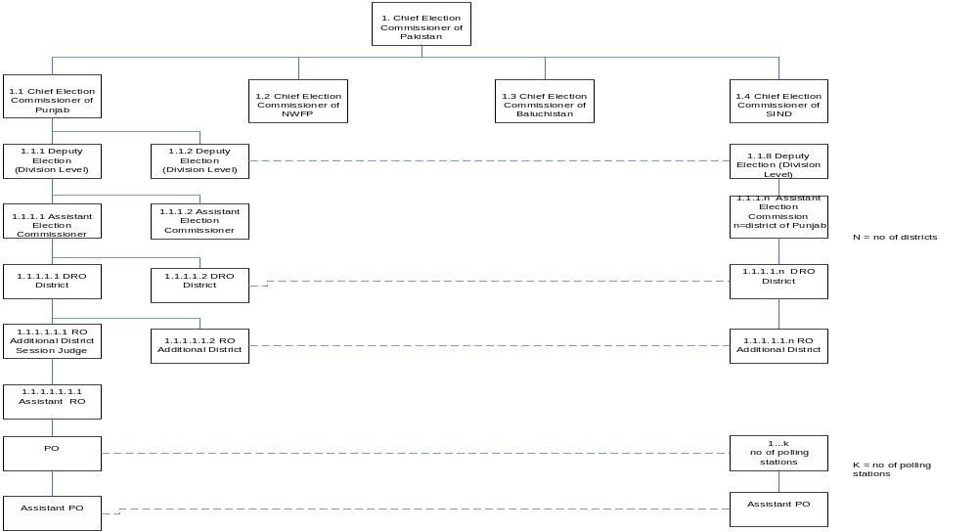 Figure 1 Business Organization Chart w.r.t Management
- Business Organization Chart with respect to types of Elections
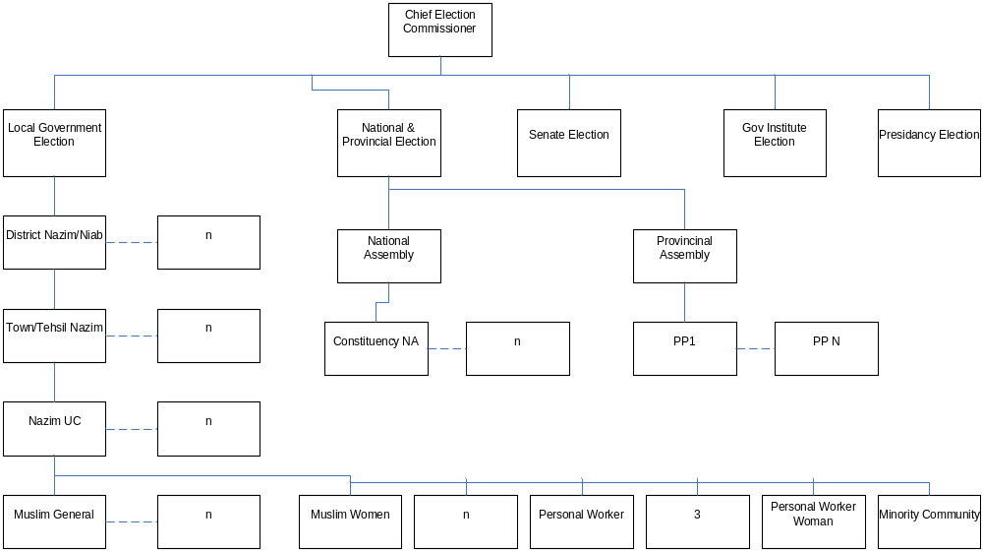Figure 2 Business Organization Chart w.r.t types of Elections
- Scope
Online Telephony Election System (OTES) will work under real environment. Candidates and voters lists will be generated automatically using our system in election commission office by using given database. These lists will be electronically distributed to the computerized polling stations. A voter can cast its vote through computerized polling stations or by using mobile phone or through website. Votes from all the three sites will be sent to a central server from their particular servers. Result will be compiled from the central server and will be dynamically updated in central election commission office after specific intervals. Final results will be sent to all main polling stations and other specific locations. There will be also a module for reporting. The candidates and voters database management will be out of OTES. We will assume that Areas and resources are already defined by election system and will be provided to OTES in some electronic form.
We have different types of elections in Pakistan. In this project we are dealing only with “Local Government Election” System.
- Summary of Requirements
Each Assistant Chief Election Commissioner (ACEC) prepares lists of voters of his province. Chief Election Commissioner (CEC) receives these lists from all ACECs. CEC proves the lists for further processing. CEC proves the lists of District Returning Officers (DROs) and Returning Officers (ROs) prepared by ACEC. Each ACEC prepares the lists of DROs for all districts under his province. Each DRO prepares the lists of ROs for all Towns/Tehsil under his district. Each RO prepares the lists of Presiding Officers, Assistant Presiding Officers and of polling staffs. CEC distributes the lists of voters to ACEC. Each ACEC distributes the lists to DROs of his province. Each DRO distributes the lists to ROs of his district. Each RO distributes the lists to POs of all polling stations in a town/tehsil. RO prepares the lists of candidates and allocate them symbol. DRO approves those lists. Result will be updated automatically during polling from PO to RO and from RO to DRO and to CEC. At the end of polling, PO will compile the result and will send unofficial result to DRO. DRO will validate the result and will send to CEC for approval.
Identifying External Entities
The Identification of External Interfaces is done in two phases.
- Over Specify Entities from Abstract
NADRA Web Service
Mobile Web Service
Election Commission Server
District Returning Officer (DRO)
Returning Officer (RO)
Assistant Returning Officer (ARO)
Presiding Officer (PO)
Assistant Presiding Officer (APO)
Chief Election Commissioner
Assistant Chief Election Commissioner Punjab
Assistant Chief Election Commissioner Sind
Assistant Chief Election Commissioner Baluchistan
Assistant Chief Election Commissioner NWFP
Polling Officer
Voter
Candidate
Polling Station
Polling Booth
- Perform Refinement
NADRA Web Service
Mobile Web Service
Election Commission Server
District Returning Officer (DRO)
Returning Officer (RO)
Presiding Officer (PO)
Chief Election Commissioner
Assistant Chief Election Commissioner Punjab
Assistant Chief Election Commissioner Sind
Assistant Chief Election Commissioner Baluchistan
Assistant Chief Election Commissioner NWFP
Voter
Candidate
Polling Station

- Context Diagram
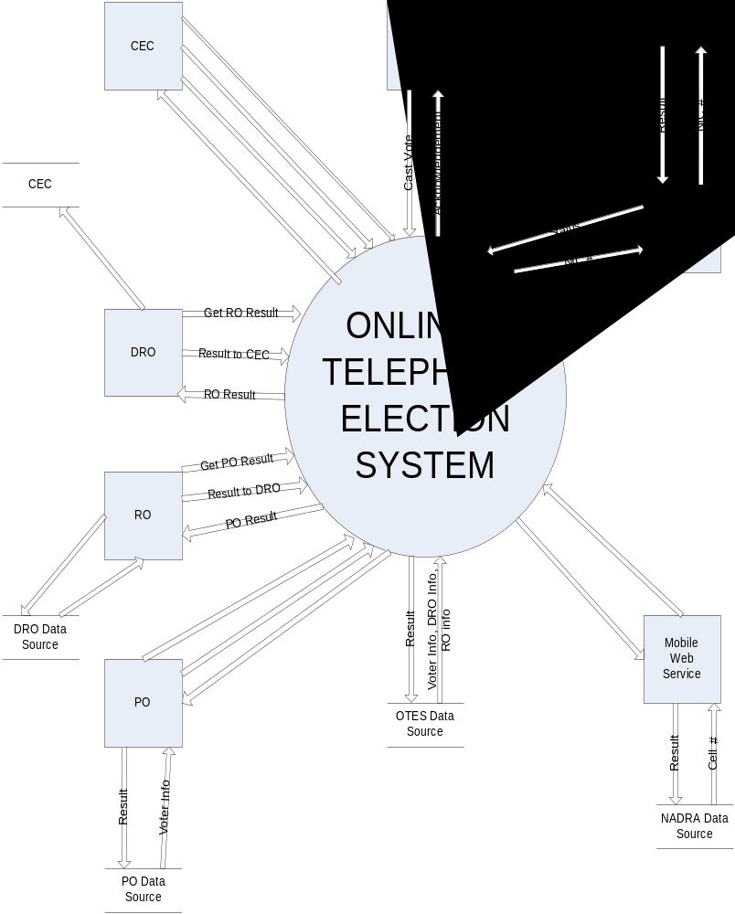 Figure 3 Business Organization Chart w.r.t Management
- Capture "shall" Statements
Para # | Initial Requirements
1.0 | Each Assistant CEC “shall” prepare electoral roll of his province.
1.0 | CEC “shall” approve electoral rolls of each province.
1.0 | Each Assistant CEC “shall” prepare selected DRO list of all the districts under his province.
1.0 | CEC “shall” approve DRO list of each province.
1.0 | Each Assistant CEC “shall” prepare selected RO list of all the Towns/Tehsils under each district.
1.0 | CEC “shall” approve RO list of each district.
1.0 | RO “shall” collect nominations from candidates.
1.0 | RO “shall” prepare final list of contesting candidates.
1.0 | RO “shall” allocate election symbols to selected candidate
1.0 | CEC “shall” distribute voter lists among DROs
1.0 | Each DRO “shall” distribute voter lists among ROs
1.0 | RO “shall” prepare list of polling stations of each Town/Tehsil and submit to DRO
1.0 | DRO “shall” approve list of polling stations
1.0 | RO “shall” prepare list of POs, APOs and polling staff and submit to DRO
1.0 | DRO “shall” approve list of POs, APOs and polling staff
1.0 | RO “shall” distribute to voter list among POs
1.0 | PO “shall” validate voter
1.0 | A voter “shall” cast vote from the polling station where the voter was registered
1.0 | A registered mobile voter “shall” cast vote from mobile where the voter was registered
1.0 | System(PO) “shall” send Polling Station result to RO
1.0 | System(RO) “shall” send Towm / Tehsil result to DRO & CEC
1.0 | System “shall” compile results that can be reviewed by PO
1.0 | PO “shall” submit results to RO
1.0 | RO “shall” prepare unofficial results on the basis of result collected from POs
1.0 | RO “shall” submit result to DRO
1.0 | DRO “shall” prepare district level results on the basis of results collected from RO
1.0 | DRO “shall” submit result to CEC
1.0 | System “shall” prepare final results
Table1 Capture Shall Requirement
- Allocate Requirements

Para # | Initial Requirements | Use Case Name
1.0 | Each Assistant CEC “shall” prepare electoral roll of his province. | UC_Prepare_ElectrolRoll
1.0 | Each Assistant CEC “shall” prepare selected DRO list of all the districts under his province. | UC_Prepare_DROList
1.0 | CEC “shall” approve DRO list of each province. | UC_Approve_DROList
1.0 | Each Assistant CEC “shall” prepare selected RO list of all the Towns/Tehsils under each district. | UC_Prepare_ROList
1.0 | CEC “shall” approve RO list of each district. | UC_Approve_ROList
1.0 | RO “shall” collect nominations from candidates. | UC_Candidate_Nomination
1.0 | RO “shall” prepare final list of contesting candidates & allocate election symbols to selected candidate | UC_Prepare_Symbol _CandidateList
1.0 | CEC “shall” distribute voter lists among DROs | UC_VoterList_DRODistribution
1.0 | Each DRO “shall” distribute voter lists among ROs | UC_VoterList_RODistribution
1.0 | RO “shall” prepare list of polling stations of each Town/Tehsil and submit to DRO | UC_Prepare_PollingStationList
1.0 | DRO “shall” approve list of polling stations | UC_Approve_PollingStationList
1.0 | RO “shall” prepare list of POs, APOs and polling staff and submit to DRO | UC_Prepare_PO_APO_PollingStaffList
1.0 | DRO “shall” approve list of POs, APOs and polling staff | UC_Approve_PO_APO_PollingStaffList
1.0 | RO “shall” distribute to voter list among POs | UC_VoterList_PODistribution
1.0 | PO “shall” validate voter | UC_Validate_Voter
1.0 | A voter “shall” cast vote from the polling station where the voter was registered | UC_Cast_Vote
1.0 | A registered mobile voter “shall” cast vote from mobile where the voter was registered | UC_Cast_MobileVote
1.0 | System “shall” compile results that can be reviewed by PO & submit results to RO | UC_Compile_Submit_POResult
1.0 | RO “shall” prepare unofficial results on the basis of result collected from POs | UC_Compile_ROResult
1.0 | RO “shall” submit result to DRO | UC_Submit_ROResult
1.0 | DRO “shall” prepare district level results on the basis of results collected from RO | UC_Compile_DROResult
1.0 | DRO “shall” submit result to CEC | UC_Submit_DROResult
1.0 | System “shall” prepare final results | UC_Compile_FinalResult
1.0 | System(PO) “shall” send Polling Station result to RO | UC_UpdateResultPOToRO
1.0 | System(RO) “shall” send Towm / Tehsil result to DRO & CEC | UC_UpdateResultROToDROCEC
Table2 Allocate Requirements
- Priorities Requirements

Para # | Rank | Initial Requirements | Use Case ID | Use Case Name
1.0 | Highest | Each Assistant CEC “shall” prepare electoral roll of his province. | UC_1 | UC_Prepare_ElectrolRoll
1.0 | Highest | RO “shall” collect nominations from candidates. | UC_2 | UC_Candidate_Nomination
1.0 | Highest | RO “shall” prepare final list of contesting candidates & allocate election symbols to selected candidate | UC_3 | UC_Prepare_Symbol _CandidateList
1.0 | Highest | CEC “shall” distribute voter lists among DROs | UC_4 | UC_VoterList_DRODistribution
1.0 | Highest | Each DRO “shall” distribute voter lists among ROs | UC_5 | UC_VoterList_RODistribution
1.0 | Highest | RO “shall” distribute to voter list among POs | UC_6 | UC_VoterList_PODistribution
1.0 | Highest | PO “shall” validate voter | UC_7 | UC_Validate_Voter
1.0 | Highest | A voter “shall” cast vote from the polling station where the voter was registered | UC_8 | UC_Cast_Vote
1.0 | Highest | PO “shall” submit results to RO | UC_9 | UC_Compile_Submit_POResult
1.0 | Highest | RO “shall” prepare unofficial results on the basis of result collected from POs | UC_10 | UC_Compile_ROResult
1.0 | Highest | RO “shall” submit result to DRO | UC_11 | UC_Submit_ROResult
1.0 | Highest | DRO “shall” prepare district level results on the basis of results collected from RO | UC_12 | UC_Compile_DROResult
1.0 | Highest | DRO “shall” submit result to CEC | UC_13 | UC_Submit_DROResult
1.0 | Highest | System “shall” prepare final results | UC_14 | UC_Compile_FinalResult
1.0 | Medium | Each Assistant CEC “shall” prepare selected DRO list of all the districts under his province. | UC_15 | UC_Prepare_DROList
1.0 | Medium | CEC “shall” approve DRO list of each province. | UC_16 | UC_Approve_DROList
1.0 | Medium | Each Assistant CEC “shall” prepare selected RO list of all the Towns/Tehsils under each district. | UC_17 | UC_Prepare_ROList
1.0 | Medium | CEC “shall” approve RO list of each district. | UC_18 | UC_Approve_ROList
1.0 | Medium | RO “shall” prepare list of polling stations of each Town/Tehsil and submit to DRO | UC_19 | UC_Prepare_PollingStationList
1.0 | Medium | DRO “shall” approve list of polling stations | UC_20 | UC_Approve_PollingStationList
1.0 | Medium | RO “shall” prepare list of POs, APOs and polling staff and submit to DRO | UC_21 | UC_Prepare_PO_APO_PollingStaffList
1.0 | Medium | DRO “shall” approve list of POs, APOs and polling staff | UC_22 | UC_Approve_PO_APO_PollingStaffList
1.0 | Medium | A registered mobile voter “shall” cast vote from mobile where the voter was registered | UC_23 | UC_Cast_MobileVote
1.0 | Highest | System(PO) “shall” send Polling Station result to RO | UC_24 | UC_UpdateResultPOToRO
1.0 | Highest | System(RO) “shall” send Towm / Tehsil result to DRO & CEC | UC_25 | UC_UpdateResultROToDROCEC
Table3 Priorities Requirements
- Requirements Traceability Matrix

Sr# | Para # | System Specification Text | Software Reqs. Spec/ Functional Req. Doc. | Build | Use Case Name | Category
1 | 1.0 | Each Assistant CEC “shall” prepare electoral roll of his province. | Activity 1,14,7,31,32 | B1 | UC_Prepare_ElectrolRoll | Business
2 | 1.0 | RO “shall” collect nominations from candidates. | Activity 15 | B1 | UC_Candidate_Nomination | Business
3 | 1.0 | RO “shall” prepare final list of contesting candidates & allocate election symbols to selected candidate | Activity 15 | B1 | UC_Prepare_Symbol _CandidateList | Business
4 | 1.0 | CEC “shall” distribute voter lists among DROs | Activity 16 | B1 | UC_VoterList_DRODistribution | Business
5 | 1.0 | Each DRO “shall” distribute voter lists among ROs | Activity 16 | B1 | UC_VoterList_RODistribution | Business
6 | 1.0 | RO “shall” distribute to voter list among POs | Activity 16 | B1 | UC_VoterList_PODistribution | Business
7 | 1.0 | PO “shall” validate voter | Activity 17 | B1 | UC_Validate_Voter | Business
8 | 1.0 | A voter “shall” cast vote from the polling station where the voter was registered | Activity 10,11 | B1 | UC_Cast_Vote | Business
9 | 1.0 | PO “shall” submit results to RO | Activity 19 | B1 | UC_Compile_Submit_POResult | Business
10 | 1.0 | RO “shall” prepare unofficial results on the basis of result collected from POs | Activity 9,13 | B1 | UC_Compile_ROResult | Business
11 | 1.0 | RO “shall” submit result to DRO | Activity 19 | B1 | UC_Submit_ROResult | Business
12 | 1.0 | DRO “shall” prepare district level results on the basis of results collected from RO | Activity 9,13 | B1 | UC_Compile_DROResult | Business
13 | 1.0 | DRO “shall” submit result to CEC | Activity 19 | B1 | UC_Submit_DROResult | Business
14 | 1.0 | System “shall” prepare final results | Activity 9  Activity 13 | B1 | UC_Compile_FinalResult | Business
15 | 1.0 | Each Assistant CEC “shall” prepare selected DRO list of all the districts under his province. | Activity 25,2,21,22 | B1 | UC_Prepare_DROList | Business
16 | 1.0 | CEC “shall” approve DRO list of each province. | Activity 25 | B1 | UC_Approve_DROList | Business
17 | 1.0 | Each Assistant CEC “shall” prepare selected RO list of all the Towns/Tehsils under each district. | Activity 25,2,21,22 | B1 | UC_Prepare_ROList | Business
18 | 1.0 | CEC “shall” approve RO list of each district. | Activity 25 | B1 | UC_Approve_ROList | Business
19 | 1.0 | RO “shall” prepare list of polling stations of each Town/Tehsil and submit to DRO | Activity 23 | B1 | UC_Prepare_PollingStationList | Business
20 | 1.0 | DRO “shall” approve list of polling stations | Activity 23 | B1 | UC_Approve_PollingStationList | Business
21 | 1.0 | RO “shall” prepare list of POs, APOs and polling staff and submit to DRO | Activity  25,2,21,22 | B1 | UC_Prepare_PO_APO_PollingStaffList | Business
22 | 1.0 | DRO “shall” approve list of POs, APOs and polling staff | Activity  25,2,21,22 | B1 | UC_Approve_PO_APO_PollingStaffList | Business
23 | 1.0 | A registered mobile voter “shall” cast vote from mobile where the voter was registered | Activity  3,4,5,6 | B1 | UC_Cast_MobileVote | Business
24 | 1.0 | System(PO) “shall” send Polling Station result to RO | Activity 19 | B1 | UC_UpdateResultPOToRO | Business
25 | 1.0 | System(RO) “shall” send Towm / Tehsil result to DRO & CEC | Activity 19 | B1 | UC_UpdateResultROToDROCEC | Business
Table4 Requirement Traceability Matrix

- High Level Usecase Diagram
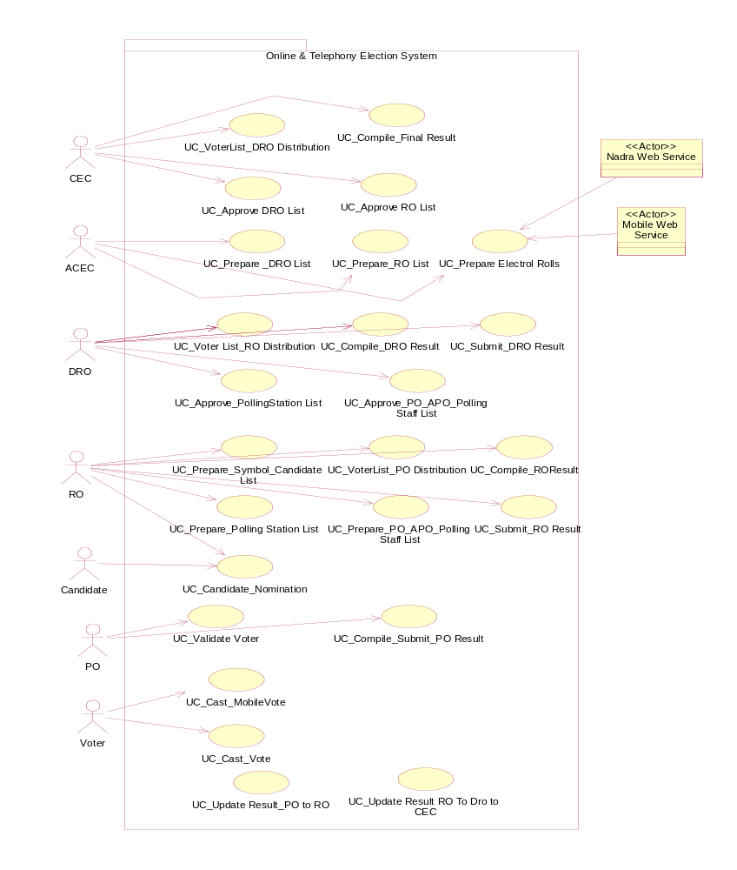
Figure 3 High Level use case diagram

- Analysis Level Use case Diagram
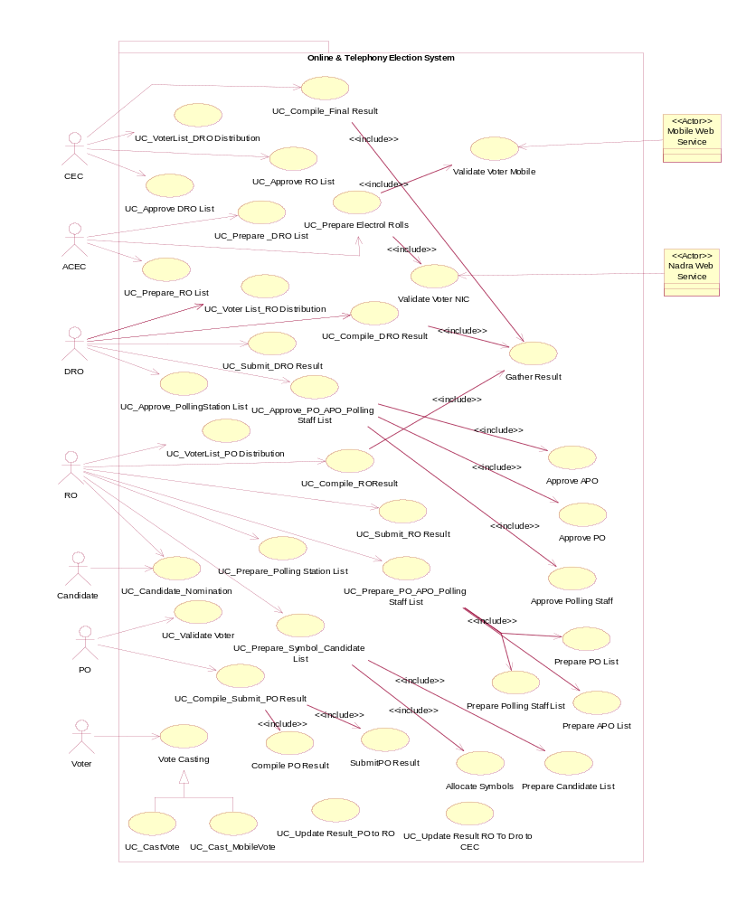
Figure 4 Analysis use case diagram
- Use case Description

Use Case Id | Use Case Name
UC_1 | - UC_Prepare_ElectorlRoll

Primary Actor: | Chief Election Commission (ACEC)
Brief Description: | ACEC enters the data. The data is validated and saved into the system. After entering all the data, electoral rolls are generated from the system.
Preconditions: | ACEC is identified and authenticated. Voter’s data entry screen is presented to ACEC for data entry.
Basic Flow: | - ACEC enters voter’s information.  - ACEC enters the mobile voter’s information.  - System verifies the voter’s NIC from web service provided by NADRA.  - ACEC confirms saving.  (ACEC repeats steps 1,2,3,4 until all data is entered)  - System generates and presents the electoral rolls lists.
Post condition: | Data of a voter will be saved and a message of confirmation will be shown to the user. Voter verification information is also saved.
Alternate Flow: | 1a. Invalid Information:  System signals error and asks for correct entry.  2a. Selection of Mobile Vote Casting:  User’s mobile number with NIC is identified from web service provided by Mobile companies.  3a. Invalid voter:  User will be flagged as invalid user.

Use Case Id | Use Case Name
UC_2 | - UC_Candidate_Nomination

Primary Actor: | Returning Officer (RO) ,Candidate
Brief Description: | After the publication of Election Schedule by the Election Commission, nomination papers are invited from interested contesting candidates.
Preconditions: | Returning Officer (RO) is identified and authenticated for particular district.  Nomination form is available to the candidates from election commission official website or gets the Nomination Form from RO office.
Basic Flow: | - Candidate downloads the nomination form from Election Commission website.  - Candidate fills in the form.  - Attached the required documentation. e.g educational background, NIC photocopy, picture etc  - Candidate submits the nomination form along with the required documents back to RO.  - RO accepts/rejects the nomination papers of candidate.
Post condition: | At the end of this use case the nominated candidate will be collected by the Returning Officer and symbols assign to qualified candidates.
Alternate Flow: | 1a. Nomination form is not available at Election Commission site  System shows message to the candidate  Candidate can get nomination form from RO office.  1b. Election Commission web server is down.  System signals error to the candidate  Candidate can get nomination form from RO office.

Use Case Id | Use Case Name
UC_3 | - UC_Prepare_Symbol _CandidateList

Primary Actor: | Returning Officer(RO)
Brief Description: | Inspection of nomination papers is carried out by the Returning Officers and nomination papers are either accepted or rejected on the basis of set rules by RO.
Preconditions: | Returning Officer (RO) is identified and authenticated for particular district.  Nomination forms of candidates are available to RO.  RO rejects the candidate who does not fulfill the set criteria.  List of Election Symbols approved by the Election Commission is available to RO.
Basic Flow: | - RO enters the id and name of selected candidate.  - RO assigns the symbol to selected candidate according to his party affiliation.  - RO assigns the symbol to individual candidates if there is any.  - RO prepares a list of selected candidates with symbols  - RO publishes the list of selected candidates with symbols.
Post condition: | Final list of contesting candidates is prepared and published in the prescribed manner by the Returning Officer after incorporation of the decisions on appeals and after withdrawal of candidature by the candidates if any.
Alternate Flow: | 3b. Db server is down  System signals error to the candidate

Use Case Id | Use Case Name
UC_4 | - UC_VoterList_DRODistribution

Primary Actor: | Chief Election Commission (CEC)
Brief Description: | CEC will distribute the voters’ lists to specific District Regional Officers. CEC will do this by uploading the lists on Web server.
Preconditions: | Data about Districts and DROs is already entered. CEC is identified and authenticated. Voters’ lists distribution screen is presented to CEC for distribution.
Basic Flow: | - CEC selects or enters District name.  - System shows basic information of district.  - CEC selects or enters DRO ID from the list.  - System shows basic information of DRO.  - CEC selects the path of the Voter Lists of the specified district.  - CEC confirms for uploading the list.  (CEC repeats steps 1, 2, 3, 4, 5, 6 until all voters’ lists are uploaded.)  - System generates and presents the lists distribution information.
Post condition: | Voters’ lists are uploaded on server. Distribution information is saved in database.
Alternate Flow: | 1a. Invalid District Name:  System signals error and asks for correct entry.  3a. Invalid DRO ID:  System signals error and asks for correct entry.  5a. Invalid List Path:  System signals error and asks for correct selection.

Use Case Id | Use Case Name
UC_5 | - UC_VoterList_RODistribution

Primary Actor: | District Returning Officer (DRO)
Brief Description: | DRO will distribute the voters’ lists to Regional Officers. DRO will do this by uploading the lists on Web server.
Preconditions: | DRO has received lists from CEC. Data about ROs is already entered. DRO is identified and authenticated. Voters’ lists distribution screen is presented to DRO for distribution.
Basic Flow: | - DRO selects or enters District name.  - System shows Towns/Teshils under that district.  - DRO selects or enters Town/Tehsil name.  - System shows basic information of Town/Tehsil.  - DRO selects or enters RO ID from the list.  - System shows basic information of RO.  - DRO selects the path of the Voter Lists of the specified Town/Teshil.  - DRO confirms for uploading the list.  - (DRO repeats steps 1, 2, 3, 4, 5, 6, 7, 8 until all voters’ lists are uploaded.)  - System generates and presents the lists distribution information.
Post condition: | Voters’ lists are uploaded on server. Distribution information is saved in database.
Alternate Flow: | 1a. Invalid District Name:  DRO can select or can enter his own district.  System signals error and asks for correct entry.  3a. Invalid Town/Teshil Name:  DRO can select or can enter Town/Teshil from the list.  System signals error and asks for correct entry.  5a. Invalid RO ID:  System signals error and asks for correct entry.  7a. Invalid List Path:  System signals error and asks for correct selection.

Use Case Id | Use Case Name
UC_6 | - UC_VoterList_PODistribution

Primary Actor: | Returning Officer (RO)
Brief Description: | RO will distribute the voters’ lists to Presiding Officers to all polling stations under his Town/Tehsil. RO will do this by uploading the lists on Web server.
Preconditions: | RO has received lists from DRO. Data about POs is already entered. RO is identified and authenticated. Voters’ lists distribution screen is presented to RO for distribution.
Basic Flow: | - RO selects or enters Town/Tehsil name.  - System shows basic information of Town/Tehsil and Polling station names.  - RO selects or enters Polling station name.  - System shows basic information of Polling station and PO name.  - RO selects the location of the voter list of the specified Polling station.  - RO confirms for uploading the list.  - (RO repeats steps 1, 3, 4, 5, 6 until all voters’ lists are uploaded.)  - System generates and presents the lists distribution information.
Post condition: | Voters’ lists are uploaded on server. Distribution information is saved in database.
Alternate Flow: | 1a. Invalid Town/Teshil Name:  1. System signals error and asks for correct entry.  3a. Invalid Polling station name:  System signals error and asks for correct entry.  5a. Invalid List Path:  System signals error and asks for correct selection.

Use Case Id | Use Case Name
UC_7 | - UC_Validate_Voter

Primary Actor: | Presiding Officer (PO)
Brief Description: | PO will validate voter on poling station on the basis of his/her NIC number.
Preconditions: | 1. PO is already login.  2. Voter lists are available for polling station.  3. Voter must come with his/her own NIC.
Basic Flow: | - PO will enter the NIC# in appropriate field  - System will validate voter from registered polling station voters list.  - System will check voter status to be true.  - PO will allocate polling booth to voter.
Post condition: | Registered authenticated voters will only access polling booth to cast vote.
Alternate Flow: | 1a. PO will enter wrong data  System will show error message  System allows him to reenter again.  2a. If voter is not registered in polling station  System will show Unregistered Voter message.  3a. If voter status is FALSE.  1. System will show Duplicate Vote message.

Use Case Id | Use Case Name
UC_8 | - UC_Cast_Vote

Primary Actor: | Voter
Brief Description: | This use case is related to vote casting by voter at polling station, which is computerized and connected with server on a network.
Preconditions: | Voter must enter Polling Station along with his NIC  Voter must be validated by the PO  PO must allocate a separate polling both to the Voter
Basic Flow: | - Voter will enter the polling both allocated by PO.  - Voter will click or press Enter button to start voting.  - Voter will select his favorite Candidate and press NEXT button.  - Voter will repeat step 3 until all categories are fulfilled  - Voter will press DONE button to end vote casting  - System will prepare final ballet paper showing his selected candidates of each category for confirmation.  - Voter will press OK button to successfully casting his vote.  - Voter status for vote casting will be disabled on the basis of NIC to prohibit multiple vote casts from single voter on polling station either from polling station or cell phone.  - An immediate disabling request for voter if he is registered for mobile vote will be send to DRO server (upper Level) to prohibit voter from mobile.
Post condition: | System will save voter vote in local DATABASE of polling station.  A successful vote casting message will be show to voter.  After a specific time local DATABASE data will be send to upper level servers.
Alternate Flow: | 4a. Voter can press Back button or select any category to go back  Voter will change candidate for selected category  Voter can repeat step 4a until to visit all previous categories.  5a. Voter can press REFRESH button to recycle for a fresh vote.  5b. Voter can press EXIT button to end Voting.  7a. Voter will press CANCEL button to go back and continue voting.

Use Case Id | Use Case Name
UC_9 | - UC_Compile_Submit_POResult

Primary Actor: | Presiding Officer(PO)
Brief Description: | Polling Station results are carried out by the Presiding Officer (PO) at the end of polling after the given time of polling. A report of results is generated for polling station. The results send to concerned Returning Officer (RO).
Preconditions: | Voting is completed.  Presiding Officer (PO) is identified and authenticated for particular polling station.
Basic Flow: | - Presiding Officer(PO) starts compiling results  - Results are calculated according to sum formula defined by Election Commission.  - Presiding Officer prepares a statement of the count indicating the number of votes secured by a candidate  - A compiled results report of particular polling station is generated.  - PO sends the report to RO.
Post condition: | The result displays locally at polling station.  A report is send to concerned RO by PO
Alternate Flow:

Use Case Id | Use Case Name
UC_10 | - UC_Compile_ROResult

Primary Actor: | Returning Officer (RO)
Brief Description: | RO receives results from all Polling stations under his Town/Tehsil. RO will compile the result for further processing. Compiled result will be shown in a Report form. This result will be of a single Town or Tehsil.
Preconditions: | All polling stations under a town or tehsil has uploaded result on the web server under their town or tehsil. Compilation screen is presented to RO for compiling result.
Basic Flow: | - RO downloads the results of all polling stations under his Town/Tehsil from the web server  - RO apply validation checks to validate the result of a polling station.  - System checks the validation of result.  - RO clicks OK button for confirmation.  - (RO repeats steps 2, 3, 4 until all results of all polling stations are validated.)  - System converts the results into a single document under the name of Town/Tehsil of RO.  - System shows the compiled result of a Town/Tehsil in a report format.
Post condition: | Validation criteria are saved. Compiled result is saved. Validation information is saved.
Alternate Flow: | 1a. Invalid or broken download link  RO sends message to specific PO for uploading the result again.  3a. Invalid Result:  System signals error and saved the result in invalid results list.

Use Case Id | Use Case Name
UC_11 | - UC_Submit_ROResult

Primary Actor: | Returning Officer (RO)
Brief Description: | All ROs submit their Towns or Teshils compiled unofficial results to DRO.
Preconditions: | RO has compiled and prepared the unofficial result. Result uploading screen is presented to RO for submitting result to DRO.
Basic Flow: | - RO selects or enters the District name.  - System shows basic information about the district.  - RO selects or enters his Town/Tehsil name.  - System shows basic information about the Town/Tehsil.  - RO selects or enters DRO ID.  - System shows basic information about the DRO.  - RO enters some description about the result.  - RO selects the path of compiled result document.  - RO confirms for uploading the result to DRO.  - System shows confirmation message for successful uploading.
Post condition: | Uploading information is saved. Result is uploaded on the web server.
Alternate Flow: | 1a. Invalid District name:  System signals error and asks for correct entry.  3a. Invalid Town/Tehsil name:  System signals error and asks for correct entry.  5a. Invalid DRO ID:  System signals error and asks for correct entry.  8a. Invalid Result document Path:  System signals error and asks for correct document path selection.

Use Case Id | Use Case Name
UC_12 | - UC_Compile_DROResult

Primary Actor: | District Returning Officer (DRO)
Brief Description: | DRO receives results from all Returning Officers under his district. DRO will compile the result for further processing. Compiled result will be shown in a Report form. This result will be of a single district.
Preconditions: | All returning officers have uploaded results of their towns or thesils on the web server. Compilation screen is presented to DRO for compiling result.
Basic Flow: | - DRO downloads the results of all ROs under his district from the web server.  - DRO apply validation checks to validate the result of a Town/Tehsil.  - System checks the validation of result.  - DRO clicks OK button for confirmation.  - (DRO repeats steps 2, 3, 4 until all results of all Towns/Tehsils under his districts are validated.)  - System converts the results into a single document under the name of district of DRO.  - System shows the compiled result of a district in a report format.
Post condition: | Validation criteria are saved. Compiled result is saved. Validation information is saved.
Alternate Flow: | 1a. Invalid or broken download link  DRO sends message to specific RO for uploading the result again.  3a. Invalid Result:  System signals error and saved the result in invalid results list.

Use Case Id | Use Case Name
UC_13 | - UC_Submit_DROResult

Primary Actor: | District Returning Officer (DRO)
Brief Description: | All DROs submit their districts compiled unofficial results to Assistant Chief Election Commission (ACEC) of specific province and Chief Election Commission (CEC).
Preconditions: | DRO has compiled and prepared the unofficial result. Result uploading screen is presented to DRO for submitting result to ACEC and CEC.
Basic Flow: | - System shows the name of CEC.  - DRO selects or enters ACEC ID of his Province.  - System shows basic information about the Province.  - DRO selects or enters the District name.  - System shows basic information about the district.  - DRO enters some description about the result.  - DRO selects the path of compiled result document.  - DRO confirms to upload the result to ACEC and CEC.  - System shows confirmation message for successful uploading.
Post condition: | Uploading information is saved. Result is uploaded on the web server.
Alternate Flow: | 2a. Invalid ACEC ID:  System signals error and asks for correct entry.  4a. Invalid district name:  System signals error and asks for correct entry.  6a. Invalid Result document Path:  System signals error and asks for correct document path selection.

Use Case Id | Use Case Name
UC_14 | - UC_Compile_FinalResult

Primary Actor: | Chief Election Commission (CEC)
Brief Description: | Chief Election Commission (CEC) compiles and approves the final result.
Preconditions: | All DROs have uploaded results of their districts on the web server. Compilation screen is presented to CEC for compiling result.
Basic Flow: | - CEC downloads the results of all DROs under all districts.  - CEC apply validation checks to validate the result of a district.  - System checks the validation of result.  - CEC clicks OK button for confirmation.  - (CEC repeats steps 2, 3, 4 until all results of all districts are validated.)  - System converts the results into a single document under the name Final result.  - System shows the Final compiled result in a report format.  - CEC approves the results.
Post condition: | Validation criteria are saved. Compiled result is saved. Validation information is saved.
Alternate Flow: | 1a. Invalid or broken download link  DRO sends message to specific RO for uploading the result again.  3a. Invalid Result:  System signals error and saved the result in invalid results list.

Use Case Id | Use Case Name
UC_15 | - UC_Prepare_DROList

Primary Actor: | Assistant Chief Election Commission (ACEC)
Brief Description: | ACEC prepares the lists of selected District Returning officers of all districts.
Preconditions: | ACEC is identified and authenticated. Data of districts and DROs is already entered.
Basic Flow: | - ACEC selects or enters the District Name.  - System shows information of district.  - ACEC selects the DRO ID.  - System shows information of DRO.  - ACEC enters the start date of the job.  - ACEC enters the end date of the job.  - ACEC confirms the appointment.  - (ACEC repeats steps 1, 3, 5, 6, 7 until all DROs are appointed to their districts.)  - System generates the list of all the appointed DROs.
Post condition: | Appointed list of DROs are saved
Alternate Flow: | 1a. Invalid District name:  System signals error and asks for correct entry.  3a. Invalid DRO ID:  System signals error and asks for correct entry.  5a. Invalid Date:  System signals error and asks for correct entry.  6a. Invalid Date:  System signals error and asks for correct entry.

Use Case Id | Use Case Name
UC_16 | UC_Approve_DROList

Primary Actor: | Assistant Chief Election Commissioner (ACEC), Chief Election Commissioner (CEC)
Brief Description: | ACEC submits the lists of selected DRO to CEC. CEC receives the lists. CEC applies some validation criteria and approves after validating the lists.
Preconditions: | CEC and ACEC are identified and authenticated. Lists of District Returning Officers are prepared.
Basic Flow: | - ACEC selects the path of list of District Returning Officers of a province.  - ACEC enters some description about the lists.  - ACEC confirms for uploading the list to CEC.  - System shows confirmation message for successful uploading.  - CEC receives list.  - CEC applies validation criteria.  - CEC approves the list.
Post condition: | Uploading information is saved. Valid and Invalid information is saved.
Alternate Flow: | 1a. Invalid lists Path:  System signals error and asks for correct document path selection.  5a. Invalid or broken download link  CEC sends message to specific ACEC for uploading the lists again.

Use Case Id | Use Case Name
UC_17 | - UC_Prepare_ROList

Primary Actor: | Assistant Chief Election Commission (ACEC)
Brief Description: | ACEC prepares the lists of selected Returning officers of all Towns/Tehsils under each district.
Preconditions: | ACEC is identified and authenticated. Data of districts, towns/tehsils and ROs is already entered.
Basic Flow: | - ACEC selects or enters the District Name.  - System shows Town/ Tehsil ID and name.  - ACEC selects or enters the Town/Tehsil ID.  - System shows basic information about Town/Tehsil.  - ACEC selects the RO ID.  - System shows information of RO.  - ACEC enters the start date of the job.  - ACEC enters the end date of the job.  - ACEC confirms the appointment.  - (ACEC repeats steps 1, 3, 5, 7, 8, 9 until all ROs are appointed to their town/tehsil.)  - System generates the list of all the appointed ROs.
Post condition: | Appointed list of ROs are saved
Alternate Flow: | 1a. Invalid District name:  System signals error and asks for correct entry.  3a. Invalid Town/Tehsil name:  System signals error and asks for correct entry.  5a. Invalid RO ID:  System signals error and asks for correct entry.  7a. Invalid Date:  System signals error and asks for correct entry.  8a. Invalid Date:  System signals error and asks for correct entry.

Use Case Id | Use Case Name
UC_18 | - UC_Approve_ROList

Primary Actor: | Assistant Chief Election Commissioner (ACEC), Chief Election Commissioner (CEC)
Brief Description: | ACEC submits the lists of selected RO to CEC. CEC receives the lists. CEC applies some validation criteria and approves after validating the lists.
Preconditions: | CEC and ACEC are identified and authenticated. Lists of all Returning Officers are prepared.
Basic Flow: | - ACEC selects or enters the District name.  - System shows basic information about the district.  - ACEC selects the path of list of Returning Officers of a district.  - ACEC enters some description about the list.  - ACEC confirms for uploading the list to CEC.  - System shows confirmation message for successful uploading.  - (ACEC repeats steps 1, 3, 4, 5 until lists of all ROs of all districts are uploaded.)  - CEC receives list.  - CEC applies validation criteria.  - CEC approves the list.
Post condition: | Uploading information is saved. Valid and Invalid information is saved.
Alternate Flow: | 1a. Invalid District name:  System signals error and asks for correct entry.  3a. Invalid lists Path:  System signals error and asks for correct document path selection.  7a. Invalid or broken download link  CEC sends message to specific ACEC for uploading the lists again.

Use Case Id | Use Case Name
UC_19 | - UC_Prepare_PollingStationList

Primary Actor: | Returning Officer (RO)
Brief Description: | RO prepares the list of polling stations under his Town/Tehsil for approval from DRO.
Preconditions: | RO is identified and authenticated. Data of districts, towns/tehsils and polling stations is already entered.
Basic Flow: | - RO selects or enters the District Name.  - System shows Town/ Tehsil ID and name.  - RO selects or enters the Town/Tehsil ID.  - System shows basic information about Town/Tehsil.  - RO enters information about a polling station.  - RO confirms the entry of polling station  - (RO repeats steps 5, 6 until all polling stations under a town/tehsil are created.)  - System generates the list of all the polling stations under the Town/Tehsil.
Post condition: | Polling stations assignment list is saved.
Alternate Flow: | 1a. Invalid District name:  System signals error and asks for correct entry.  3a. Invalid Town/Tehsil name:  System signals error and asks for correct entry.  5a. Wrong entry:  System signals error and asks for correct entry.

Use Case Id | Use Case Name
UC_20 | - UC_Approve_PollingStationList

Primary Actor: | District Returning Officer (DRO), Returning Officer (RO)
Brief Description: | RO submits the lists of polling stations to DRO. DRO receives the lists. DRO applies some validation criteria and approves after validating the lists.
Preconditions: | RO and DRO are identified and authenticated. Lists of polling stations are prepared.
Basic Flow: | - RO selects or enters the District name.  - System shows basic information about the district.  - RO selects or enters his Town/Tehsil name.  - System shows basic information about the Town/Tehsil.  - RO selects or enters DRO ID.  - System shows basic information about the DRO.  - RO selects the path of list of polling stations under a Town/Tehsil.  - RO enters some description about the lists.  - RO confirms for uploading the result to DRO.  - System shows confirmation message for successful uploading.  - DRO receives list.  - DRO applies validation criteria.  - DRO approves the list.
Post condition: | Uploading information is saved. Valid and Invalid information is saved.
Alternate Flow: | 1a. Invalid District name:  System signals error and asks for correct entry.  3a. Invalid Town/Tehsil name:  System signals error and asks for correct entry.  5a. Invalid DRO ID:  System signals error and asks for correct entry.  7a. Invalid lists Path:  System signals error and asks for correct document path selection.

Use Case Id | Use Case Name
UC_21 | - UC_Prepare_PO_APO_PollingStaffList

Primary Actor: | Returning Officer (RO)
Brief Description: | RO prepares the list of Presiding officers, Assistant Presiding Officers and Polling staff of all polling stations under his Town/Tehsil for approval from DRO.
Preconditions: | RO is identified and authenticated. Data of districts, towns/tehsils, Polling Stations, Presiding officers (PO), Assistant Presiding officers (APO) is already entered.
Basic Flow: | - RO selects or enters the District Name.  - System shows Town/ Tehsil ID and name.  - RO selects or enters the Town/Tehsil ID.  - System shows basic information about Town/Tehsil.  - RO selects or enters the Polling station ID.  - System shows information of Polling station.  - RO selects or enters the PO ID.  - System shows information of PO.  - RO selects or enters the APO ID.  - System shows information of APO.  - RO selects or enters the Polling staff IDs.  - System shows information of polling staff information.  - RO confirms the assignment.  - (RO repeats steps 5, 7, 9, 11, 13 until all PO, APO and polling staff are appointed to all polling stations.)  - System generates the list of all the assigned PO, APO and polling staffs.
Post condition: | All POs, APOs and polling staff list are saved.
Alternate Flow: | 1a. Invalid District name:  System signals error and asks for correct entry.  3a. Invalid Town/Tehsil name:  System signals error and asks for correct entry.  5a. Invalid Polling station ID:  System signals error and asks for correct entry.  7a. Invalid PO ID:  System signals error and asks for correct entry.  9a. Invalid APO ID:  System signals error and asks for correct entry.  11a. Invalid Polling staff ID:  System signals error and asks for correct entry.

Use Case Id | Use Case Name
UC_22 | - UC_Approve_PO_APO_PollingStaffList

Primary Actor: | District Returning Officer (DRO), Returning Officer (RO)
Brief Description: | RO submits the lists of POs, APOs, Polling staff to DRO. DRO receives the lists. DRO applies some validation criteria and approves after validating the lists.
Preconditions: | RO and DRO are identified and authenticated. Lists of POs, APOs, polling staff are prepared.
Basic Flow: | - RO selects or enters the District name.  - System shows basic information about the district.  - RO selects or enters his Town/Tehsil name.  - System shows basic information about the Town/Tehsil.  - RO selects or enters DRO ID.  - System shows basic information about the DRO.  - RO selects the path of lists of POs, APOs, polling staff under a polling station.  - RO enters some description about the lists.  - RO confirms for uploading the lists to DRO.  - (RO repeats steps 7, 8, 9 until all PO, APO and polling staff lists are uploaded.)  - System shows confirmation message for successful uploading.  - DRO receives lists.  - DRO applies validation criteria.  - DRO approves the lists.
Post condition: | Uploading information is saved. Valid and Invalid information is saved.
Alternate Flow: | 1a. Invalid District name:  System signals error and asks for correct entry.  3a. Invalid Town/Tehsil name:  System signals error and asks for correct entry.  5a. Invalid DRO ID:  System signals error and asks for correct entry.  7a. Invalid lists Path:  System signals error and asks for correct document path selection.  11a. Invalid or broken download link  DRO sends message to specific RO for uploading the lists again.

Use Case Id | Use Case Name
UC_23 | - UC_Cast_MobileVote

Primary Actor: | Voter
Brief Description: | This use case is related to vote casting by voter from their cell phones.
Preconditions: | Voter mobile connection must be issued on his NIC basis.  Voter must be registered for mobile voting in Electoral roles.  Voter must receive PASSWORD through SMS few hours before election timings.
Basic Flow: | - Voter will type NIC*PASSWORD  - Voter NIC & PASSWORD will be authenticated.  - Voter voting status will be verified to be true.  - Voter will listen welcome tape.  - Voting tape will be played giving voter options for candidate of specific category in a defined sequence.  - Voter will press appropriate option button to select candidate.  - Repeat step 3 and step 4 up to number of categories.  - Voter will press hash(#) button to end vote casting  - System will prepare final ballet paper audio showing his selected candidates of each category for confirmation.  - Voter will press OK button to successfully cast his vote.  - Voter status for vote casting will be disabled on the basis of NIC to prohibit multiple vote casts from single voter.  - A disabling request for voter will be send to specific polling immediately where voter is registered to prohibit voter from online vote of polling station afterwards.
Post condition: | System will save voter vote in local DATABASE of DRO system.  A successful vote casting tape will be voter.  After a specific time local DATABASE data will be send to upper level servers.
Alternate Flow: | 2a. Voter violate format or wrongly input data  1. Play invalid input tape for user  2. Give voter an option to reenter data  3. repeat step 2 three times then end call  3a. Voter voting status found false  Play warning tape that you have already cast vote.  Immediately end call.  6a. Voter enters wrong option  Play wrong option tape and ask for valid input  repeat step 1 three times then end call session  8a. Voter enters any other button instead of hash (#).  Play wrong option tape and ask to press hash (#).  repeat step 1 three times then end call session  10a. Voter want to change vote  Voter will press back(c) button to repeat voting  repeat step 1 three times then end call session

Use Case Id | Use Case Name
UC_24 | - UC_UpdateResultPOToRO

Primary Actor: | System
Brief Description: | System at every PO level will send the result to specific RO system after a specific time. On RO side system will update database and will show the updating of results dynamically.
Preconditions: | System is in running state. Votes are being cast on Polling stations.
Basic Flow: | - System checks the updating time.  - System prepares a result for updating to RO data base.  - System attaches some information of Polling station, DRO etc with the result.  - System sends result to RO system.  - RO System receives the results from each polling station after an interval and update in database.  - RO system shows the updating result on screen.
Post condition: | Updating result is saved in RO database. Changes are recorded in database.
Alternate Flow: | 2a. No new vote is cast in specific time:  System will send only a message to RO system.  4a. Result sending problem:  System internally saves the problem and asks user for specific settings.

Use Case Id | Use Case Name
UC_25 | - UC_UpdateResultROToDROCEC

Primary Actor: | System
Brief Description: | System at every RO level will send the result to specific DRO system and to CEC system after a specific time. On RO side system will update the result and will show the updating of results dynamically.
Preconditions: | System is in running state. Results have been updated on ROs levels.
Basic Flow: | - System checks the updating time.  - System prepares a result for updating to specific DRO and CEC data bases.  - System attaches some information with the result.  - System sends result to specific DRO and CEC systems.  - Specific DRO and CEC System receive the results from each RO after an interval and update in databases.  - Specific DRO and CEC system shows the updating result on screen.
Post condition: | Updating result is saved in Specific DRO and CEC databases. Changes are recorded in database.
Alternate Flow: | 2a. No new result is updated on RO system.  System will send only a message to DRO and CEC systems.  4a. Result sending problem:  System internally saves the problems and asks user for specific settings.

